Chapter 6

Amazon in India

Trade regulations, payment systems, entrenched competition, cloud technology expansion

World trade flows reflect interdependencies among industries, countries, and regions.

These flows manifest in country, company, industry & regional exports and imports.

China is world’s leading exporter, US is world’s leading importer

The difference between the monetary value of a nation’s exports and imports is called the [**balance of trade**](https://html1-cluster-e.mheducation.com/smartbook2/data/151626/highlighted_epubmhe/OPS/s9ml/glossary.xhtml#key-balance-of-trade). When a country’s exports exceed its imports, it incurs a surplus in its balance of trade. When imports exceed exports, a deficit results. World trade trends in U.S. exports and imports are reflected in the U.S. balance of trade.

In the last 30 years, imports have exceeded exports every year and the volume of exports and imports have both increased dramatically.

4 largest importers of US products: Canada, Mexico, China & Japan.

4 largest exporters to the US: China, Canada, Mexico, & Japan.

Five trends have significantly influenced the landscape of global marketing:

* Trend 1: Gradual decline of economic protectionism by individual countries.
* Trend 2: Formal economic integration and free trade among nations.
* Trend 3: Global competition among global companies for global customers.
* Trend 4: Emergence of a networked global marketspace.
* Trend 5: Growing prevalence of economic espionage.

The major industrialized nations of the world formed the [**World Trade Organization (WTO)**](https://html1-cluster-e.mheducation.com/smartbook2/data/151626/highlighted_epubmhe/OPS/s9ml/glossary.xhtml#key-World-Trade-Organization-WTO) in 1995 to address an array of world trade issues. There are 162 WTO member countries, including the United States, which account for more than 90 percent of world trade. The WTO is a permanent institution that sets rules governing trade between its members through panels of trade experts who decide on trade disputes between members and issue binding decisions. The WTO reviews more than 200 trade disputes annually.

A number of countries with similar economic goals have formed transnational trade groups or signed trade agreements for the purpose of promoting free trade among member nations and enhancing their individual economies. Two of the best-known examples are the European Union (or simply EU) and the North American Free Trade Agreement (NAFTA)

The European Union currently consists of 28 member countries that have eliminated most barriers to the free flow of products, services, capital, and labor across their borders

US leader in **gross domestic product (GDP)** – monetary value of all products and services produced in a country in one year

**Trade feedback effect** – imports affect exports and vice versa

**Countertrade** - An estimated 10 to 15 percent of world trade this way. the practice of using barter rather than money for making global sales.

[**Protectionism**](https://html1-cluster-e.mheducation.com/smartbook2/data/151626/highlighted_epubmhe/OPS/s9ml/glossary.xhtml#key-protectionism) - the practice of shielding one or more industries within a country’s economy from foreign competition through the use of tariffs or quotas.

[**Tariffs**](https://html1-cluster-e.mheducation.com/smartbook2/data/151626/highlighted_epubmhe/OPS/s9ml/glossary.xhtml#key-tariffs) - a government tax on products or services entering a country, primarily serve to raise prices on imports.

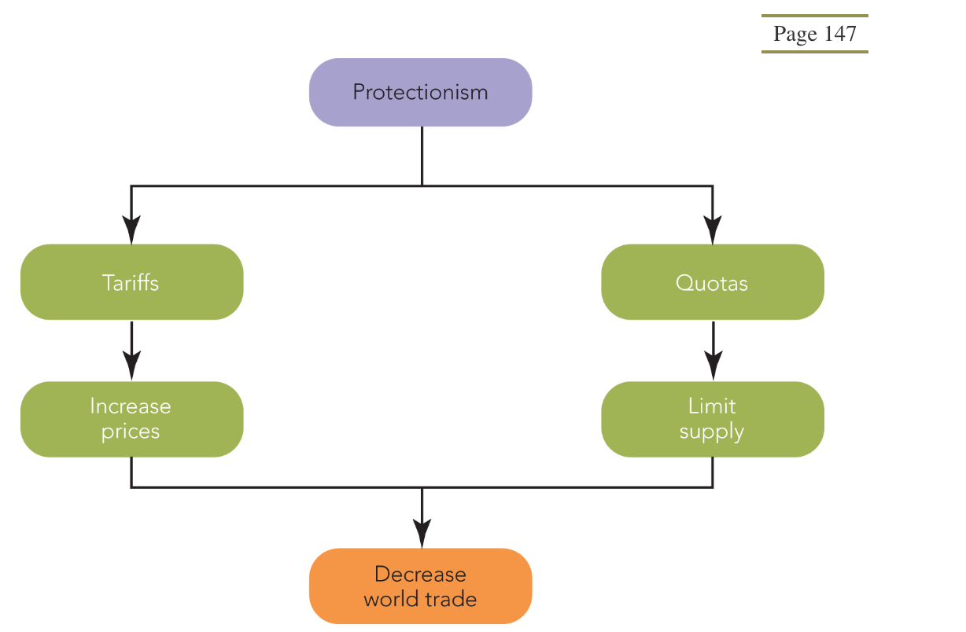

[**quota**](https://html1-cluster-e.mheducation.com/smartbook2/data/151626/highlighted_epubmhe/OPS/s9ml/glossary.xhtml#key-quota) - is a restriction placed on the amount of a product allowed to enter or leave a country. Quotas can be mandated or voluntary and may be legislated or negotiated by governments. Import quotas seek to guarantee domestic industries access to a certain percentage of their domestic market.